Test Case: tc001_SPX_Dev5_Crear_Solicitud_Articulo_Almacen
Step 1 - Enter username and password and click to button Enter : Credentials Entered
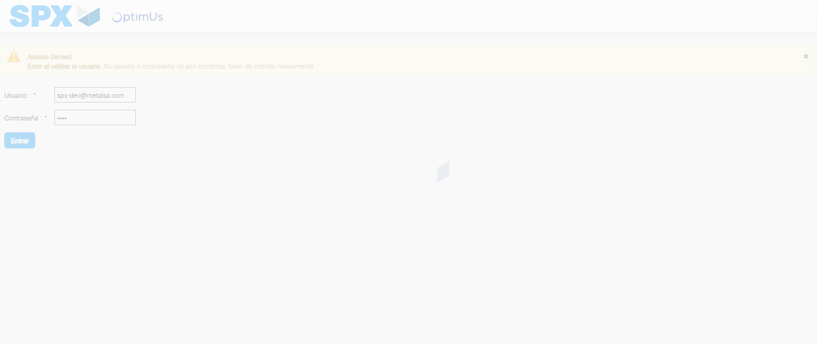Image file-name: QC_Testing-tc001_SPX_Dev5_Crear_Solicitud_Articulo_Almacen-1787931761400

Step 2 - Select to UEN and Access to Request for a New Inventory Item : UEN Correctly selected and Correct access
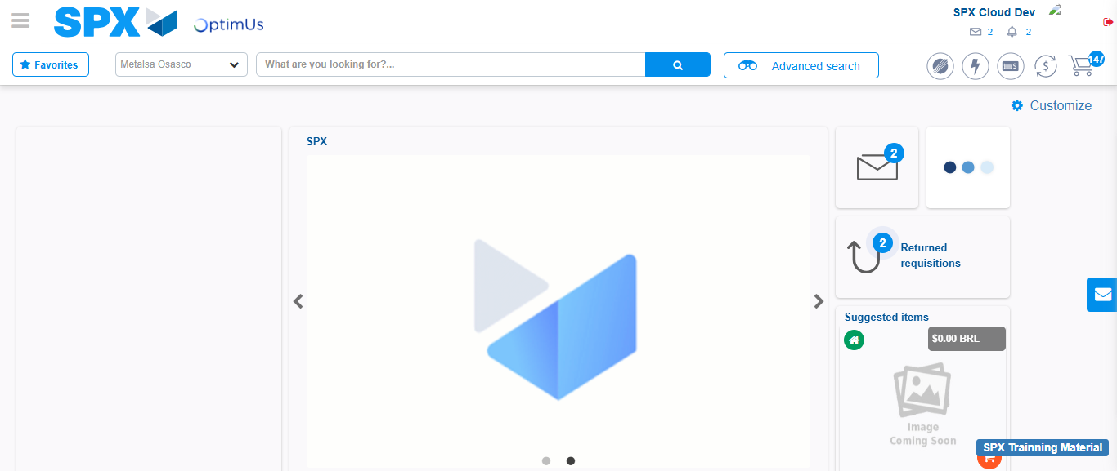Image file-name: QC_Testing-tc001_SPX_Dev5_Crear_Solicitud_Articulo_Almacen-1787931787661

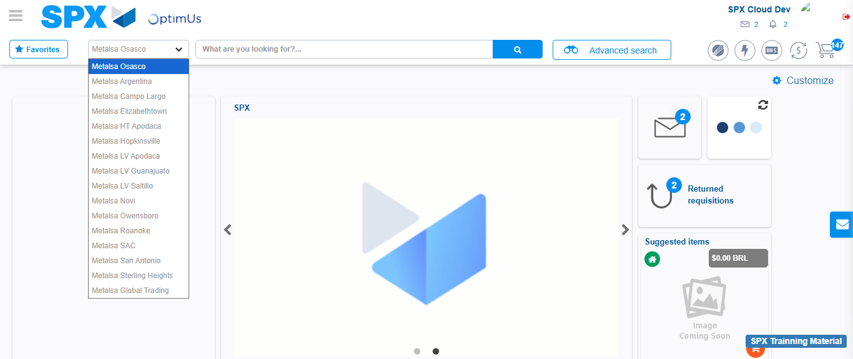Image file-name: QC_Testing-tc001_SPX_Dev5_Crear_Solicitud_Articulo_Almacen-1787931788344

Image file-name: QC_Testing-tc001_SPX_Dev5_Crear_Solicitud_Articulo_Almacen-1787931812586

Step 3 - Select options first section : Options seleted correctly
Image file-name: QC_Testing-tc001_SPX_Dev5_Crear_Solicitud_Articulo_Almacen-1787931812842

Image file-name: QC_Testing-tc001_SPX_Dev5_Crear_Solicitud_Articulo_Almacen-1787931813009

Step 4 - Select options at Screen: Options seleted correctly
Image file-name: QC_Testing-tc001_SPX_Dev5_Crear_Solicitud_Articulo_Almacen-1787931812842

Image file-name: QC_Testing-tc001_SPX_Dev5_Crear_Solicitud_Articulo_Almacen-1787931813009

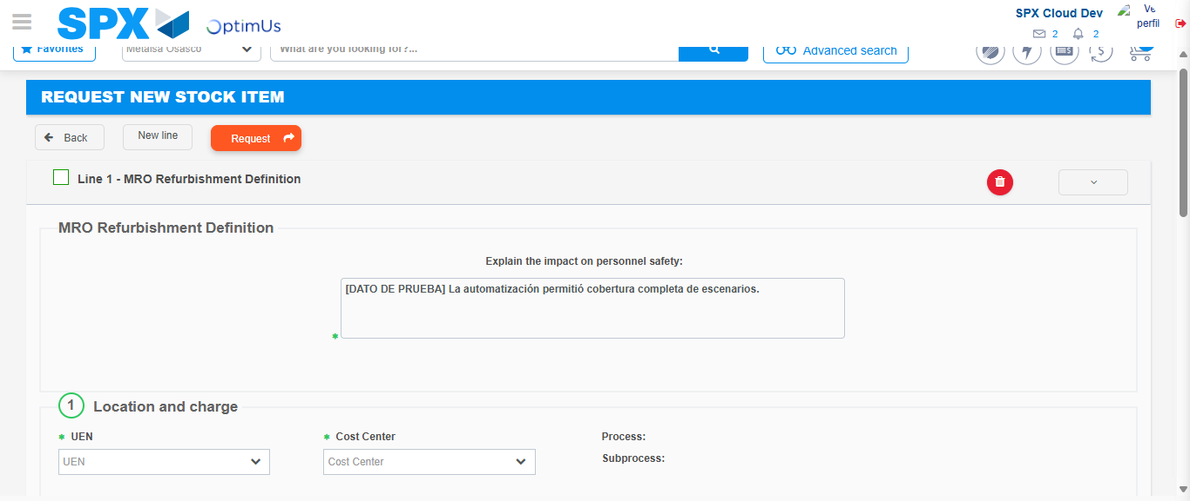Image file-name: QC_Testing-tc001_SPX_Dev5_Crear_Solicitud_Articulo_Almacen-1787931819287

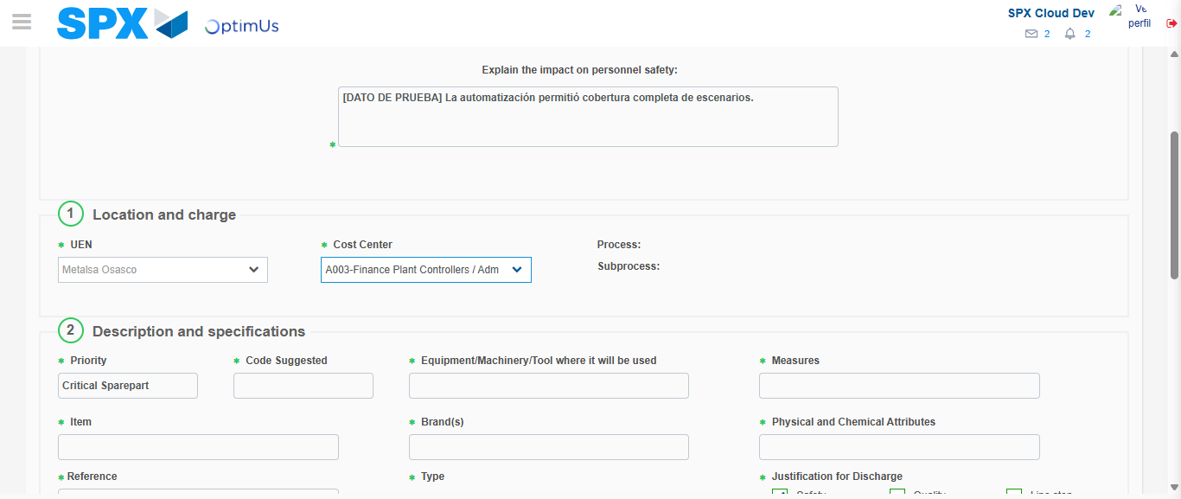Image file-name: QC_Testing-tc001_SPX_Dev5_Crear_Solicitud_Articulo_Almacen-1787931822032

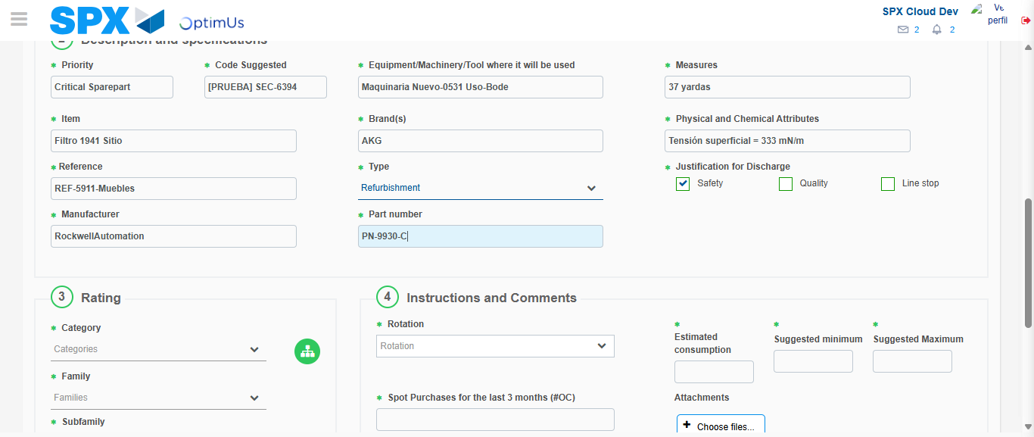Image file-name: QC_Testing-tc001_SPX_Dev5_Crear_Solicitud_Articulo_Almacen-1787931823785

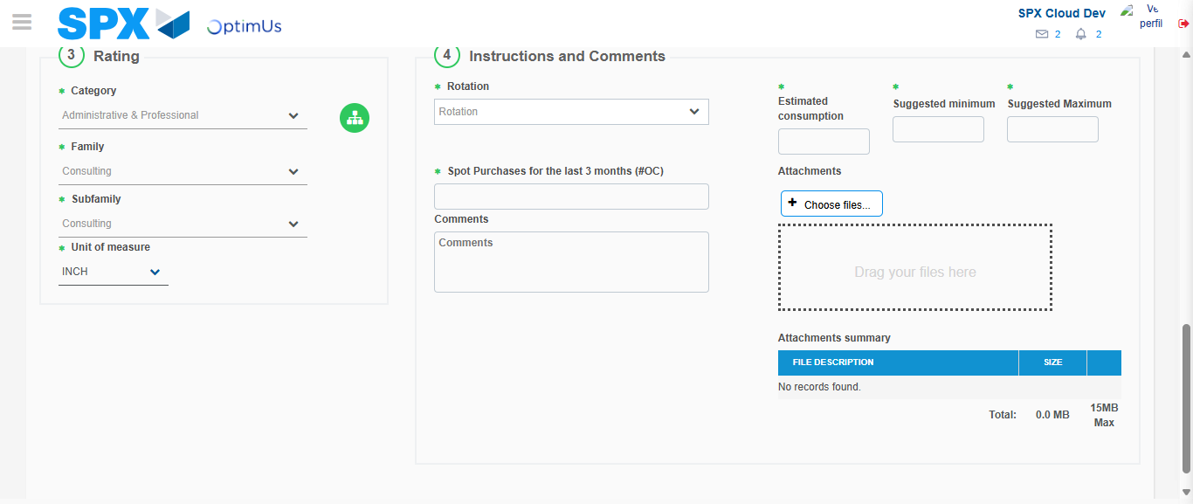Image file-name: QC_Testing-tc001_SPX_Dev5_Crear_Solicitud_Articulo_Almacen-1787931828723

Step 5 - Request New Item : Request Accepted
Image file-name: QC_Testing-tc001_SPX_Dev5_Crear_Solicitud_Articulo_Almacen-1787931787661

Image file-name: QC_Testing-tc001_SPX_Dev5_Crear_Solicitud_Articulo_Almacen-1787931788344

Image file-name: QC_Testing-tc001_SPX_Dev5_Crear_Solicitud_Articulo_Almacen-1787931812586

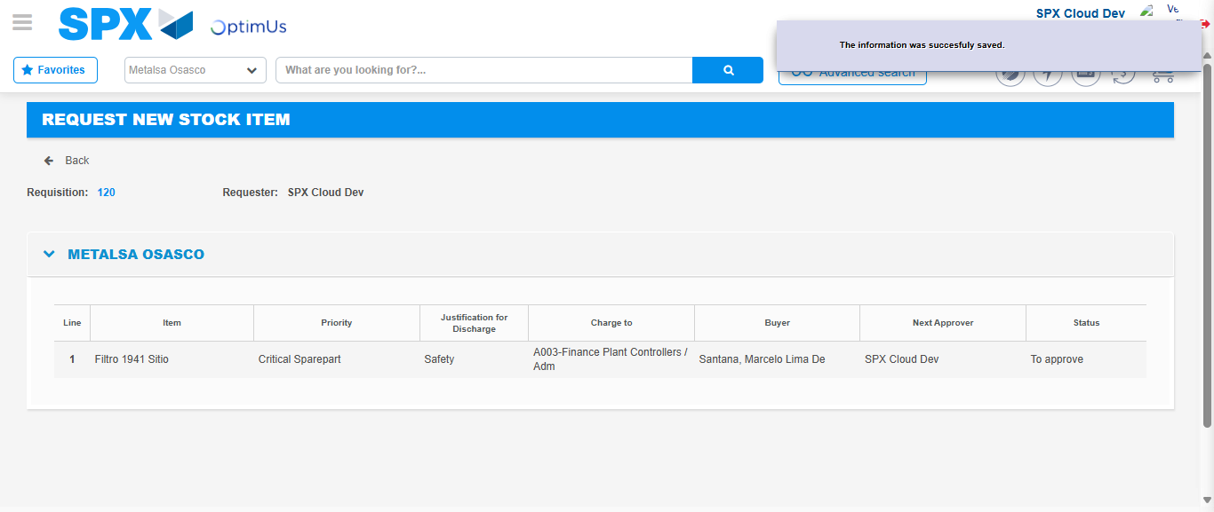Image file-name: QC_Testing-tc001_SPX_Dev5_Crear_Solicitud_Articulo_Almacen-1787931835945

Image file-name: QC_Testing-tc001_SPX_Dev5_Crear_Solicitud_Articulo_Almacen-1787931836125

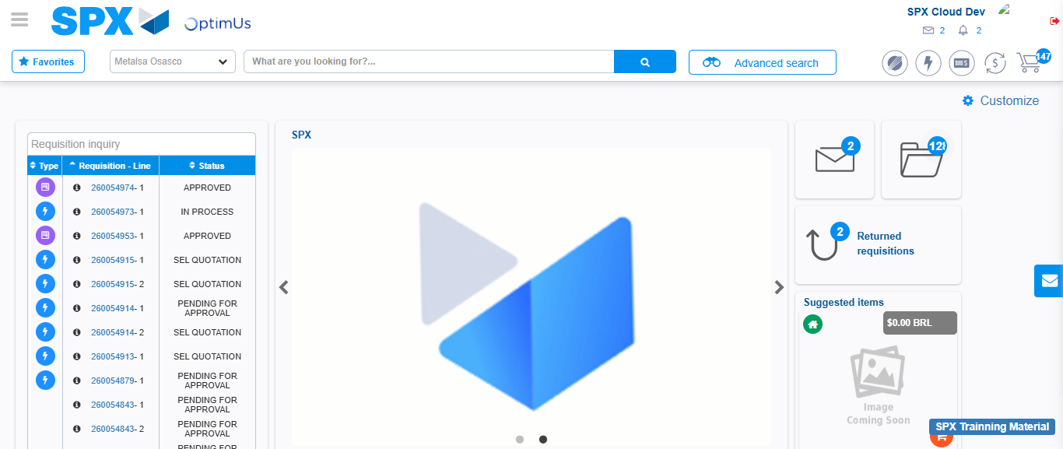Image file-name: QC_Testing-tc001_SPX_Dev5_Crear_Solicitud_Articulo_Almacen-1787931857403

Step 7 - Return to Main Page SPX : Return to Main Page SPX
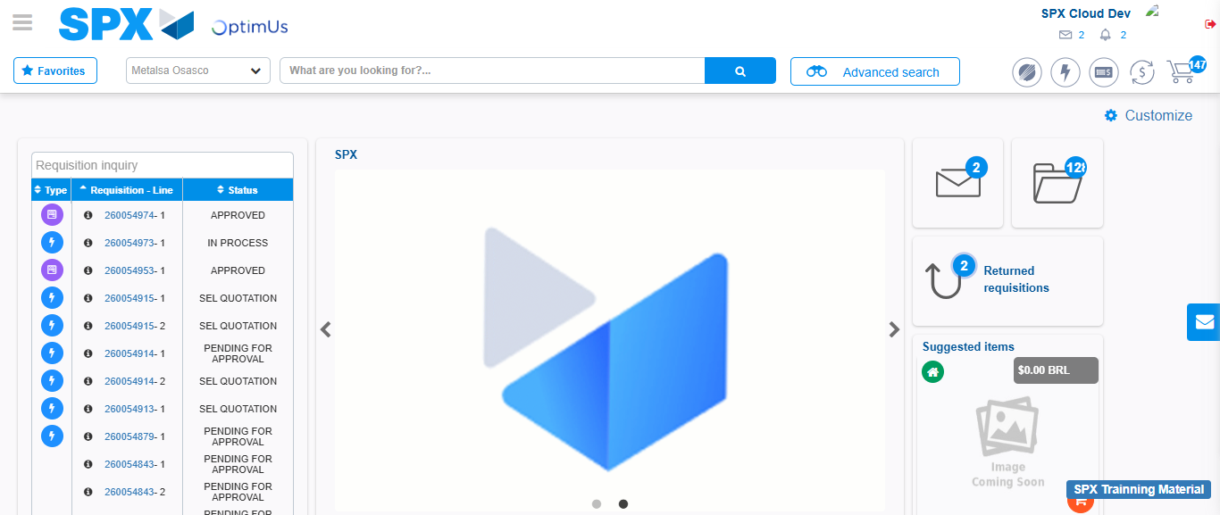Image file-name: QC_Testing-tc001_SPX_Dev5_Crear_Solicitud_Articulo_Almacen-1787931857747

